

**DIPLOMA IN COMPUTER SCIENCE**

**SCHOOL OF COMPUTING**

**Assessment: Individual Project**

|  |  |
| --- | --- |
| **Course Code:** | **DCS3003** |
| **Course Name:** | **Website Design** |
| **Academic Session:** | **September – December 2024** |
| **Lecturer’s Name:** | **Ms Teo Choon Yeh** |

|  |  |
| --- | --- |
| **Release Date:** | **6th September 2024** |
| **Submission Due Date:** | **24th  November 2024** |

**Weightage**

**)**

**%**

**(**

**:**

**20**

**Marks**

**Obtained**

**:**



**20**

**Student’s Declaration**

I certify that this assignment is my own work, and appropriately acknowledged wherever material adapted from other sources. I understand that plagiarism, cheating, collusion, fraud, fabrication or falsifications of data are not acceptable. I agree that if at any time it is shown that I have significantly misrepresented material submitted to Crescendo International College, any marks or credits awarded to me on the basis of that material may be revoked.

|  |  |  |  |
| --- | --- | --- | --- |
| **Student Name** | WONG RONG XIN | **Student ID** | DCS2404061 |
| **Signature** |  | **Date** | 24 November 2024 |

**Table of Content**

**Introduction** 4

**Contents** 5

**First webpage** 5

**Second webpage** 6

**Third webpage** 7

**Fourth webpage** 8

**Fifth webpage** 9

**Sixth webpage** 10

**Seventh webpage** 11

**Sketch of my website** 12

**Conclusion** 13

**Reference List** 14

# **Introduction**

The website design for tourism shall develop an attractive and user-friendly website that will form the basis of presenting to visitors all travel destinations, attractions and services. That's cardinal in inspiring visits, planning and bookings, availing them with photos, guides and customer reviews that make them comfortable. A good tourism website should be catchy, easy to use and responsive on any devices especially for mobile phone, while ensuring seamlessness of experience for users. It also needs access to further features such as maps, booking options and language support to help facilitate customers from around the world. Tourism website development will bring destinations alive on the Internet and help users find out more about places they may want to visit. This would be possible through evocative photography and videos, clear descriptions of attractions and useful information such as travel tips, itineraries and culture. Hence, It requires an intuitive design that will sail the user smoothly around such features as search bars, filters and booking systems. Interactive touches include things like maps for virtual tours, customer reviews to improve the experience and make it more immersive and trustworthy. The points of convenience, inspiration and accessibility that a good tourism website should focus on are captured by dreaming up, planning and booking such a perfect trip with ease.

# **Contents**

**First webpage**: Introduce about this website and what services will be provided.

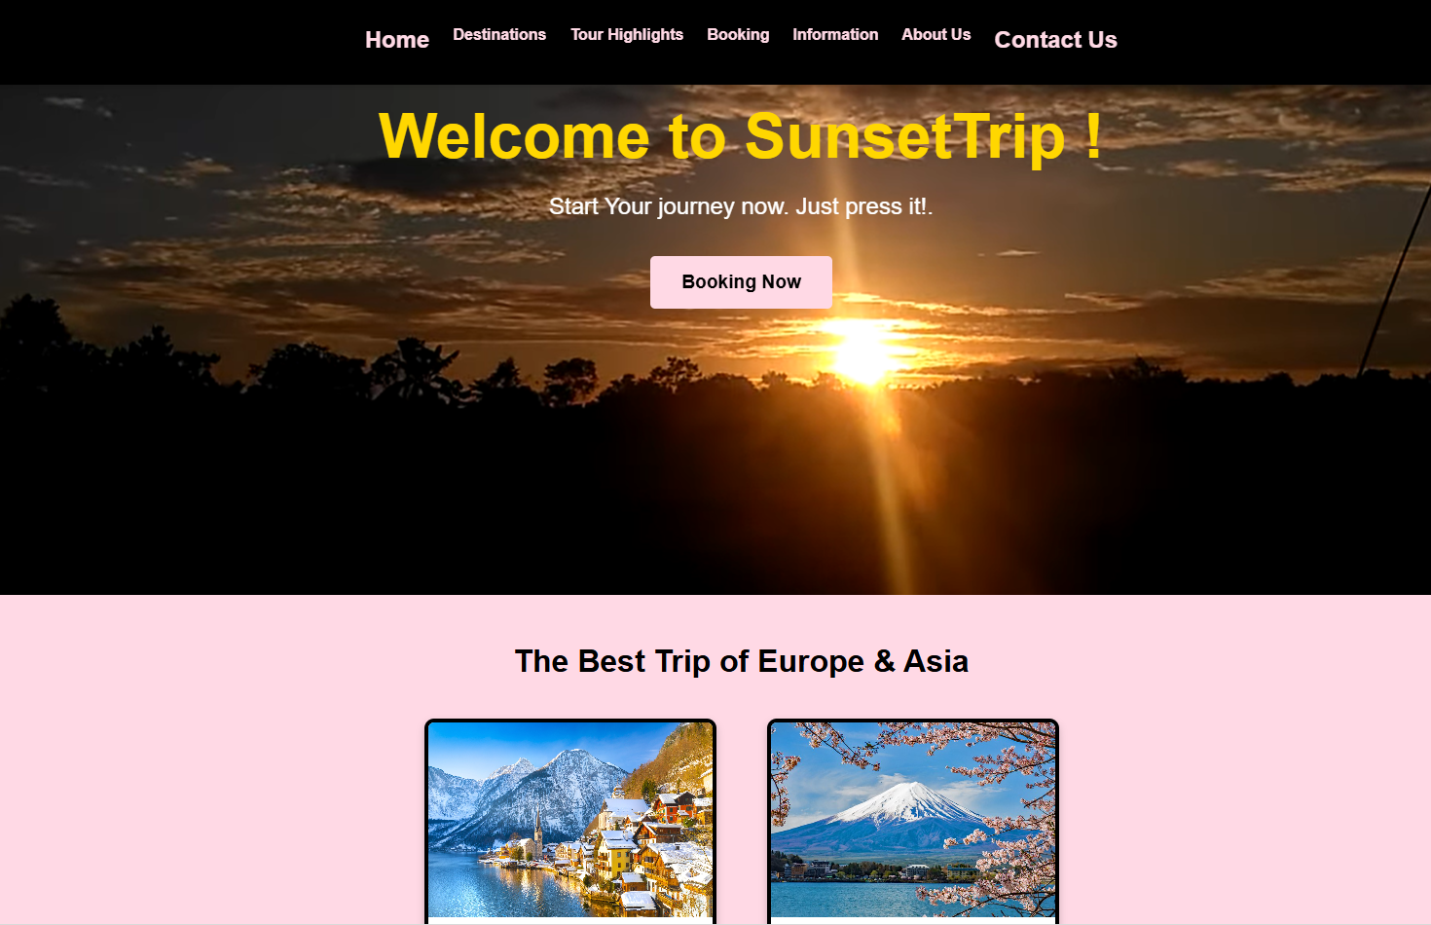

**Second webpage**: Explain the most popular destination and the estimated costs.

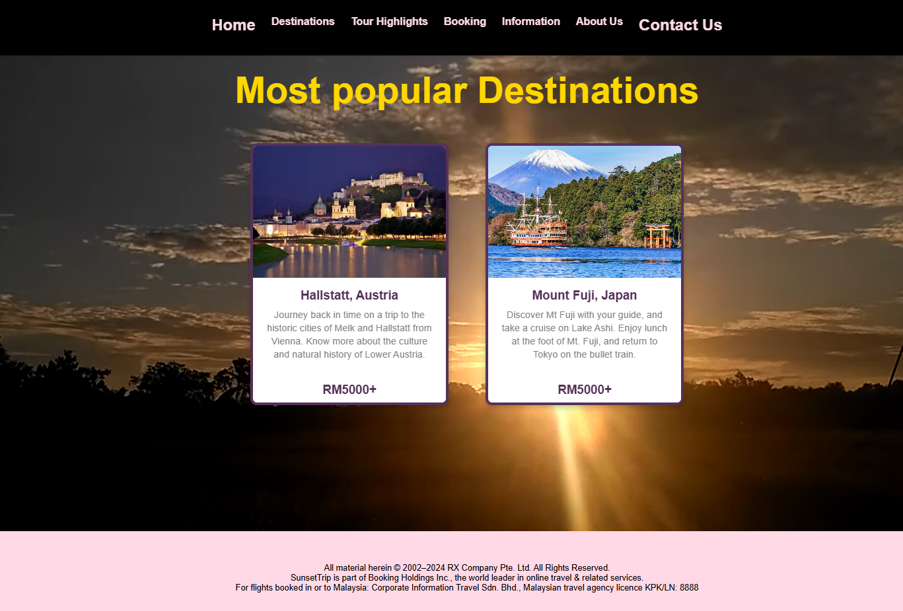

**Third webpage**: To show the detail of those packages and the highlights.

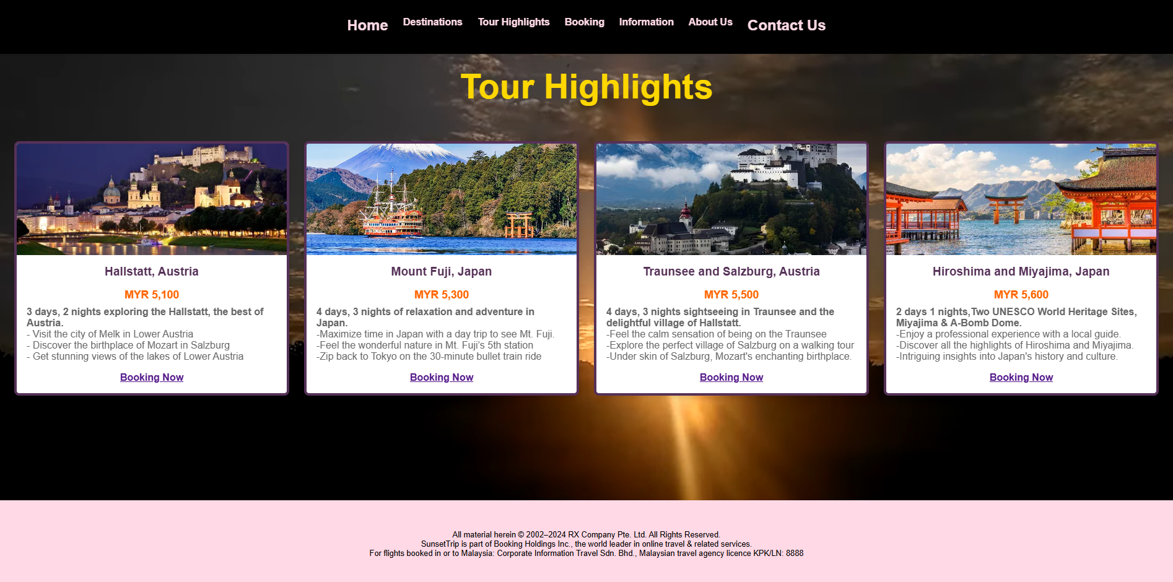

**Fourth webpage**: To provide a form for user to fill in personal information.

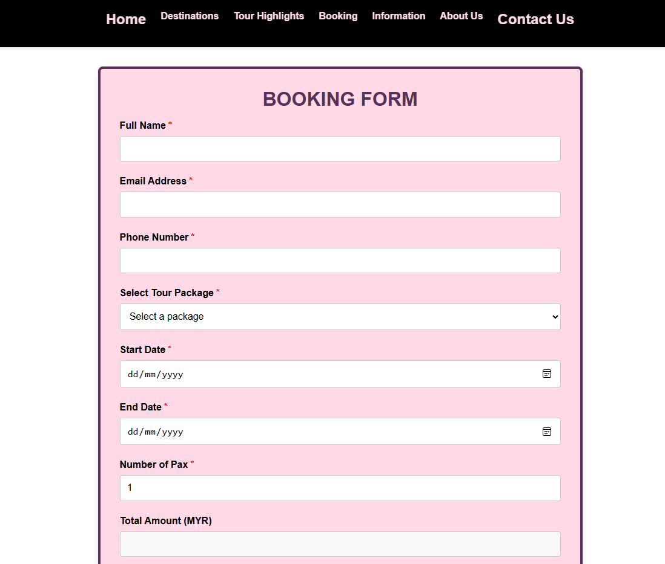

**Fifth webpage**: Provide a necessary note for potential users to remind them about custom clearance.

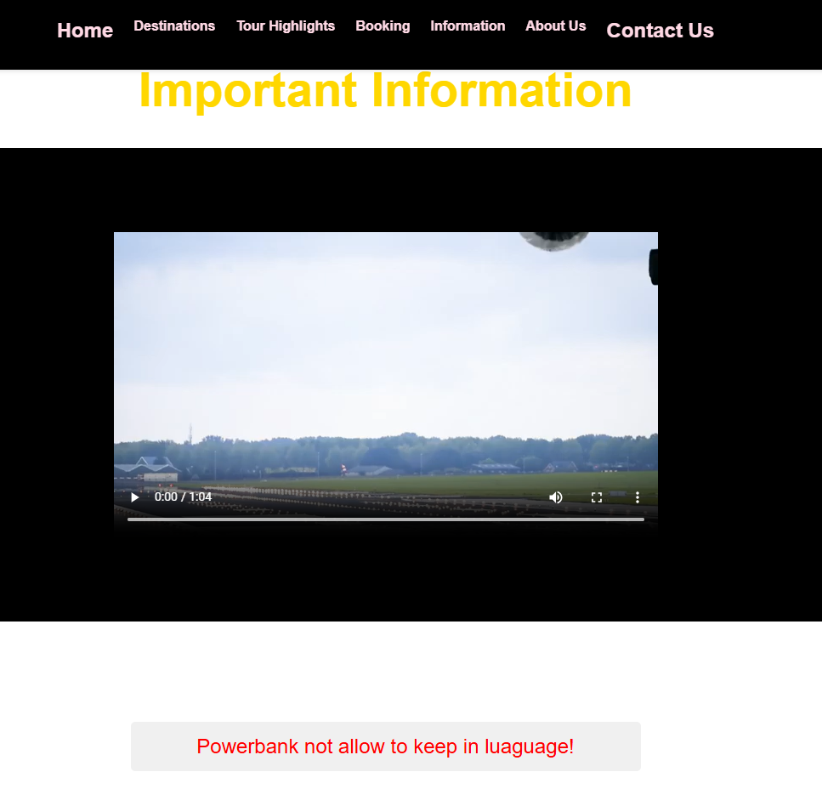

**Sixth webpage**: To build up the trust with users and provide an overview of company reputation.

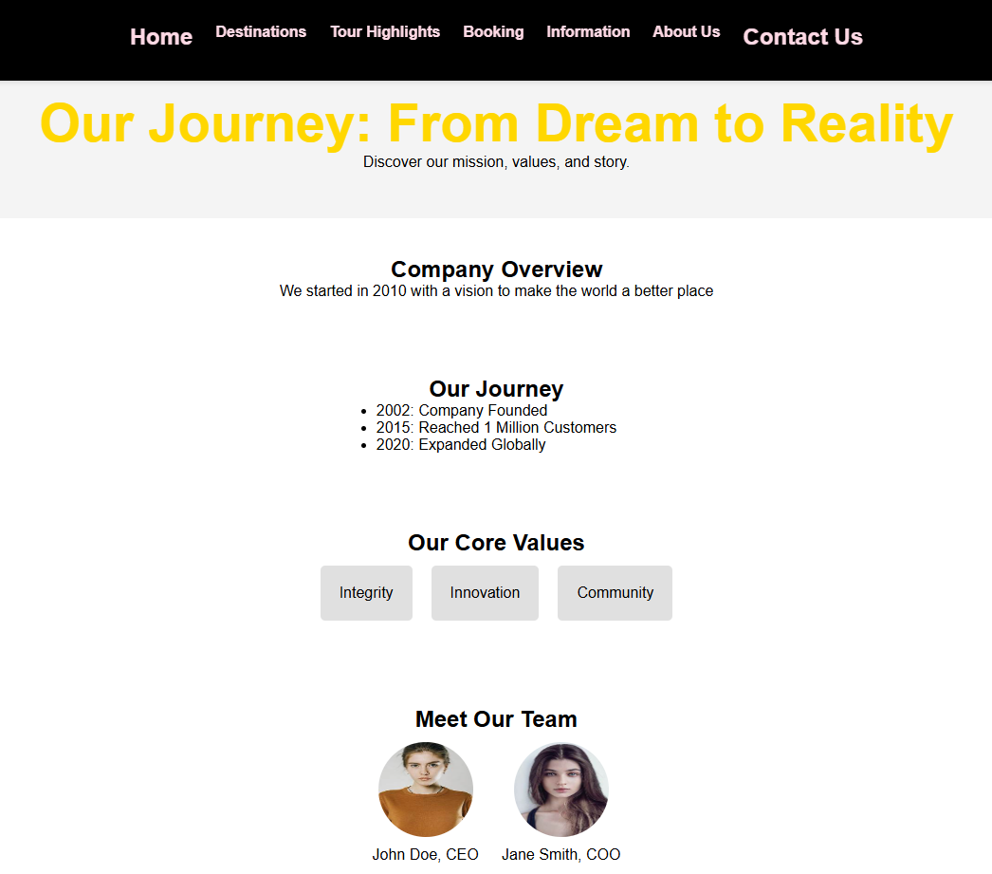

**Seventh webpage**: Provide contact info and a form for users to give feedback or enquiry.

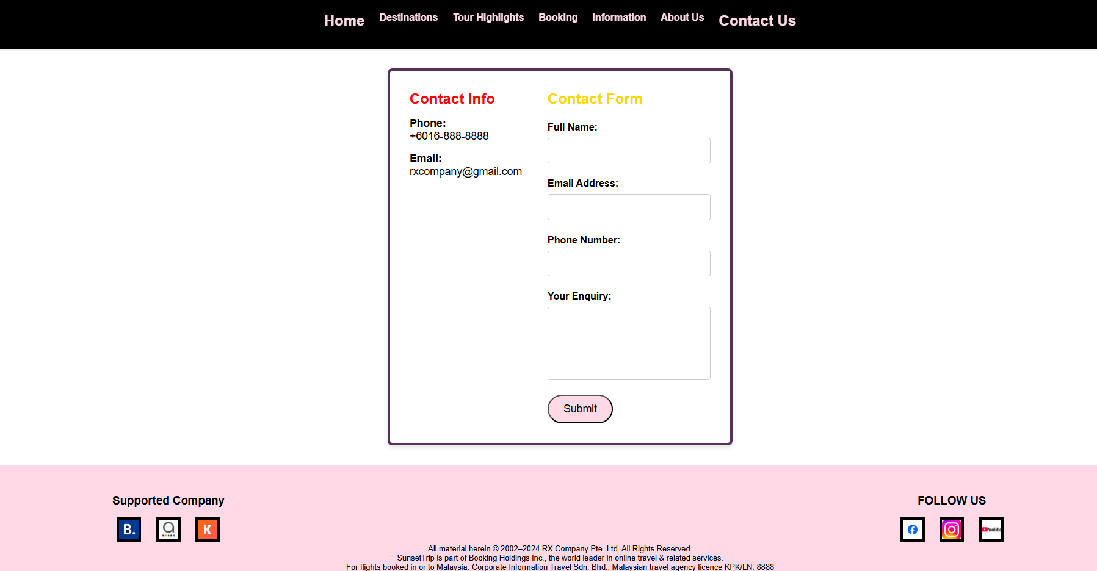

**Sketch of my website**:

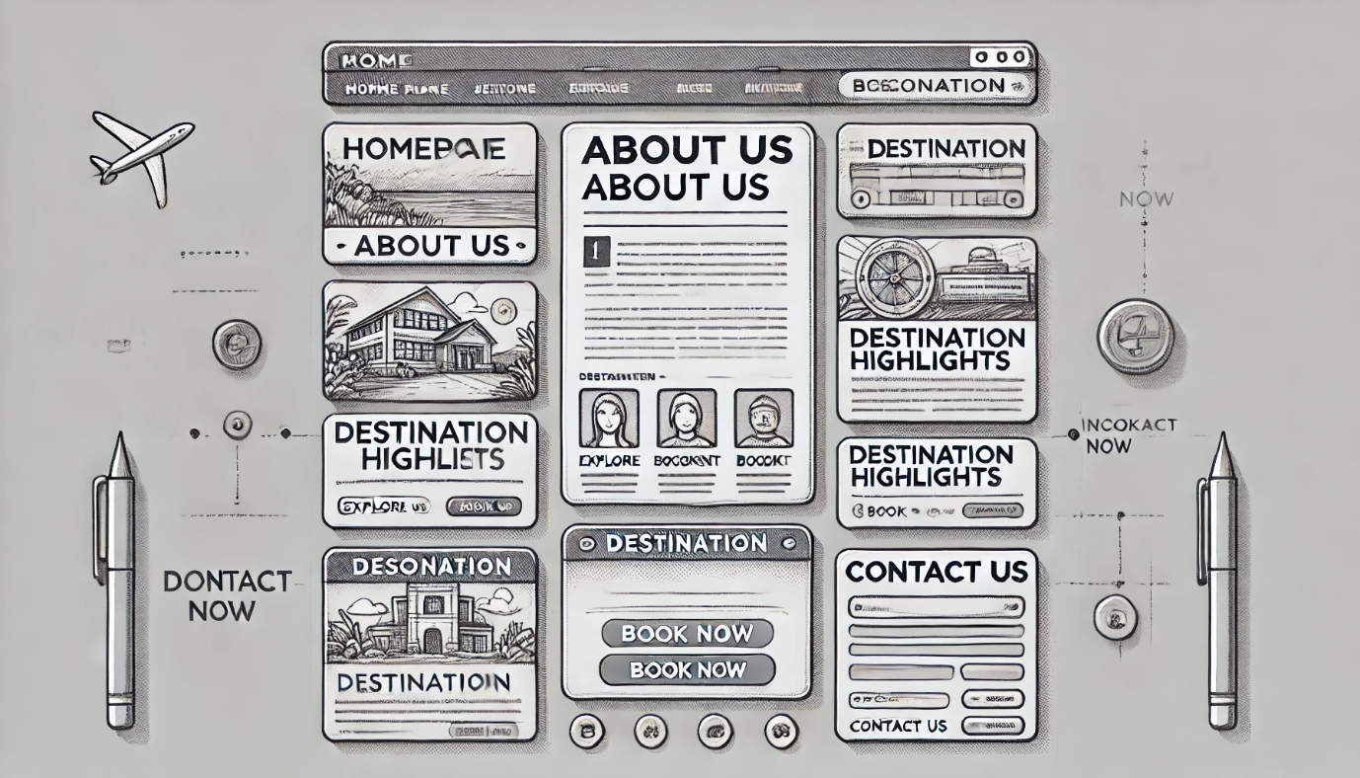

# **Conclusion**

A good tourism website would make the world accessible without making one feel that planning a trip is a chore. It combines stunning visuals with ease of navigation and will include booking features and travel guides, catering to both veterans and first-time travellers. A good tourism website does indeed inspire tourists with attractive pictures and stories while providing all the necessary information with full confidence in tour planning. It includes interactive maps, virtual tours and customer reviews that breed trust and fun among audiences. Most importantly, it ensures accessibility on a variety of devices. Therefore, enabling users to access it at any time and any place for planning trips. Ensuring comfort, inspiration and a seamless user experience, the tourism website will serve as the trusted companion in the discovery and exploration of new destinations by encouraging people to make travel dreams realities.

# **Reference List**

1. admin (2024). *Travel/Tourism Website Using HTML and CSS (Code + Demo)*. [online] CodeWithRandom. Available at:

<https://www.codewithrandom.com/2024/02/18/travel-website-using-html-css/>.

1. ‌Jena, M. (2023). *Designing a Travel and Tourism Website in HTML and CSS*. [online] Medium. Available at:

<https://medium.com/@mjena/designing-a-travel-and-tourism-website-in-html-and-css-4ac98125a46d>.

1. Quicksprout.com. (2019). *5 Easy Steps to Creating a Sitemap For a Website*. [online] Available at:

<https://www.quicksprout.com/creating-website-sitemap/>.

1. Pexels.com. (2024). *Pexels*. [online] Available at:

<https://www.pexels.com/search/tourism/>.

1. ‌Unsplash (n.d.). *500+ Tourism Pictures | Download Free Images on Unsplash*. [online] unsplash.com. Available at:

<https://unsplash.com/images/travel/tourism>.

1. ‌Pexels.com. (2024). *Pexels*. [online] Available at:

<https://www.pexels.com/search/videos/tourism/>.

1. Bing. (2021). *how to sketch a website design - Bing*. [online] Available at:

<https://www.bing.com/images/search?q=how+to+sketch+a+website+design&qpvt=how+to+sketch+a+website+design&form=IGRE&first=1>.

1. Writer, L.P. (2024). *27 of the best places to visit in Europe*. [online] Lonely Planet. Available at:

<https://www.lonelyplanet.com/articles/best-places-to-visit-europe>.